1. Use Selenium IDE to automate the login process for the Flipkart website, ensuring the test script waits for the home page to load after login.Use the 'wait for element' command to confirm the user dashboard or profile icon is visible after logging in.
Ans:
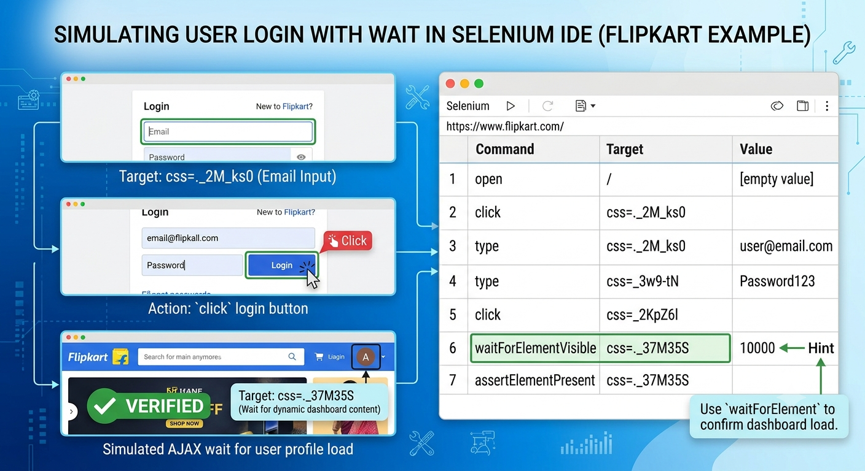

2. Record a Selenium IDE test that adds two products to the cart on Myntra, then verifies that both items appear in the cart summary.
Ans:
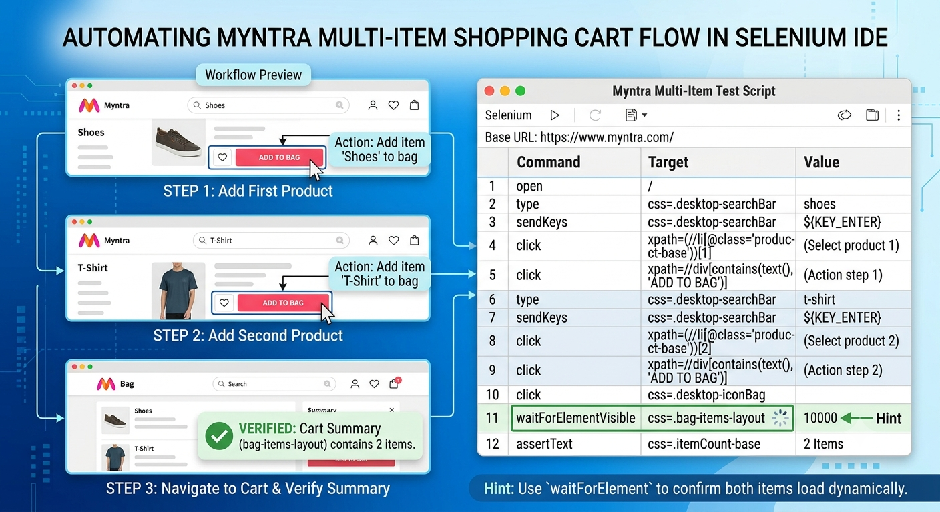

3. Create a Selenium IDE script to log out of your Zomato account after adding an item to the cart, and validate that the login page is displayed again.
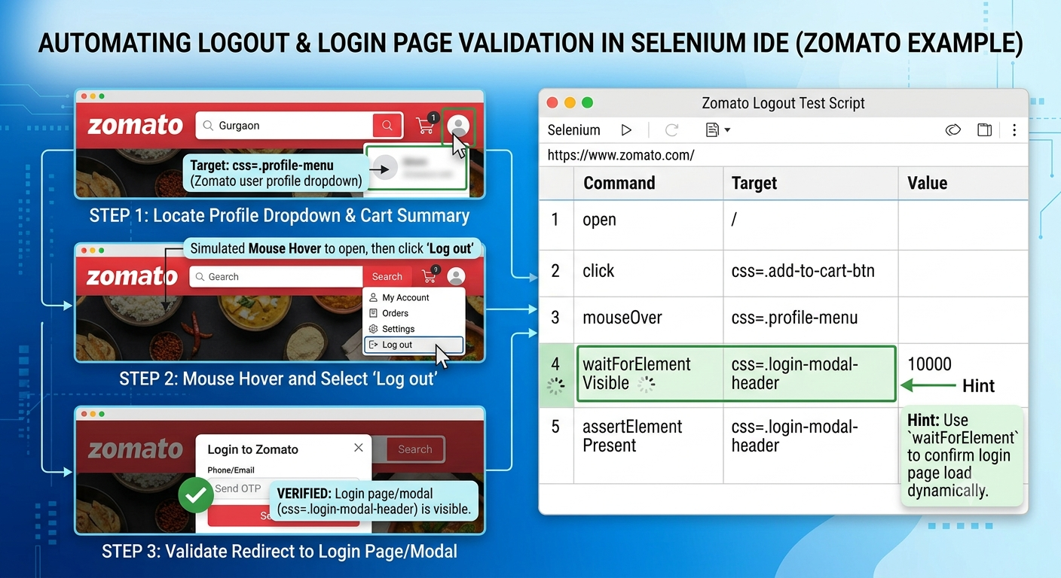

4. Export your Selenium IDE test suite as a test plan document, including steps for login, adding items, cart validation, and logout, and briefly describe the expected result for each step.\
Ans:

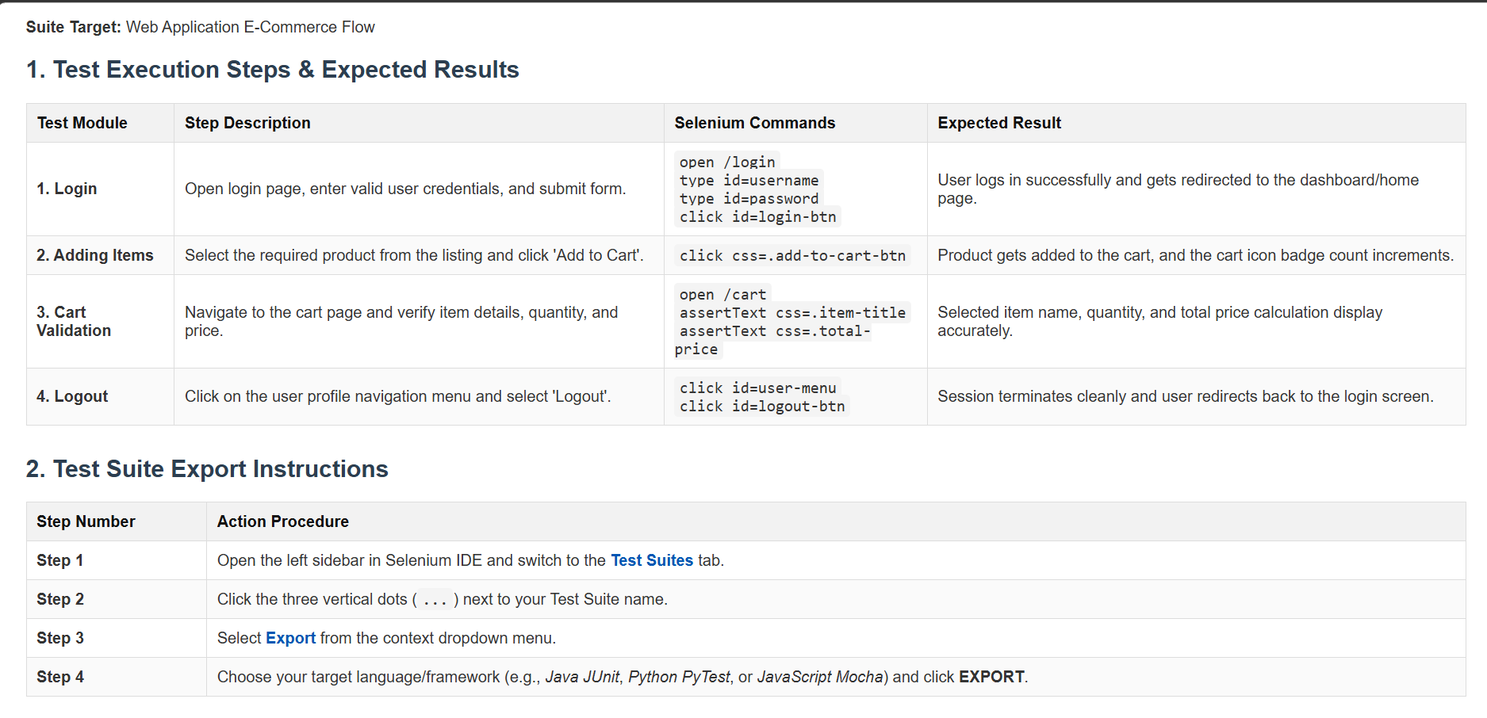

5. Build a full regression test suite in Selenium IDE for the Swiggy website covering login, searching for a restaurant, adding a dish to the cart, and logging out. Ensure your suite includes at least one validation step for content (e.g., dish name or price).
Ans
